1 Modelo de entidade e Relacionamento

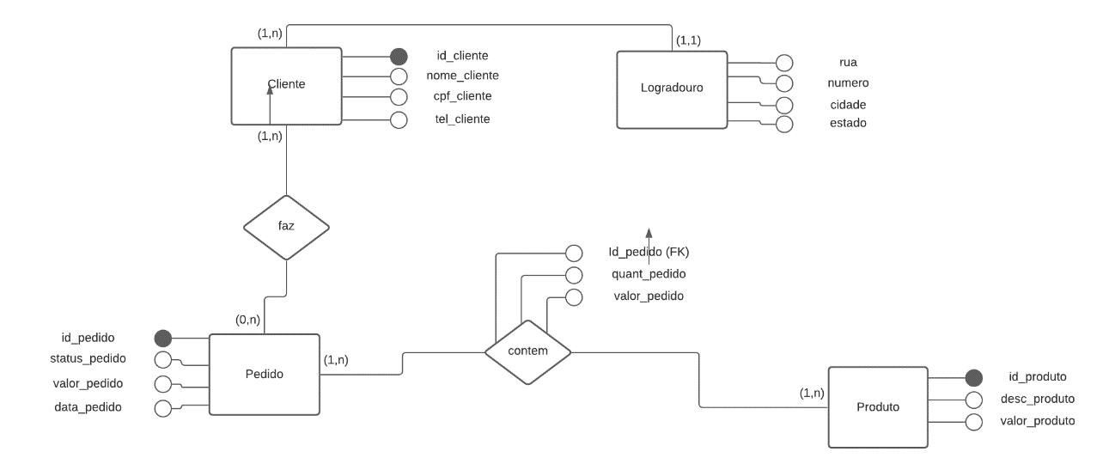

2 Modelo relacional

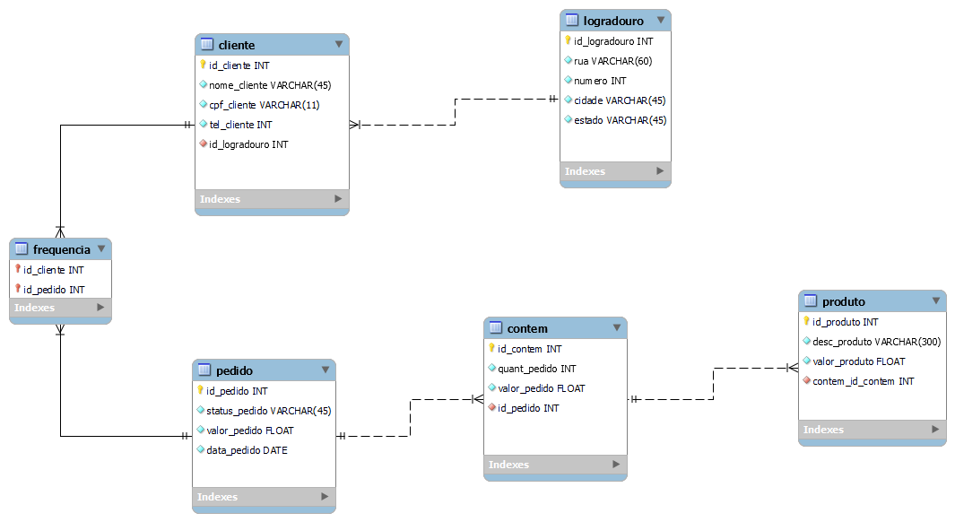

3 Modelo Fisico

-- MySQL Script generated by MySQL Workbench

-- Fri May 7 18:56:25 2021

-- Model: New Model Version: 1.0

-- MySQL Workbench Forward Engineering

SET @OLD_UNIQUE_CHECKS=@@UNIQUE_CHECKS, UNIQUE_CHECKS=0;

SET @OLD_FOREIGN_KEY_CHECKS=@@FOREIGN_KEY_CHECKS, FOREIGN_KEY_CHECKS=0;

SET @OLD_SQL_MODE=@@SQL_MODE, SQL_MODE='ONLY_FULL_GROUP_BY,STRICT_TRANS_TABLES,NO_ZERO_IN_DATE,NO_ZERO_DATE,ERROR_FOR_DIVISION_BY_ZERO,NO_ENGINE_SUBSTITUTION';

-- -----------------------------------------------------

-- Schema pizzaria

-- -----------------------------------------------------

-- -----------------------------------------------------

-- Schema pizzaria

-- -----------------------------------------------------

CREATE SCHEMA IF NOT EXISTS `pizzaria` DEFAULT CHARACTER SET utf8 ;

USE `pizzaria` ;

-- -----------------------------------------------------

-- Table `pizzaria`.`logradouro`

-- -----------------------------------------------------

CREATE TABLE IF NOT EXISTS `pizzaria`.`logradouro` (

`id_logradouro` INT NOT NULL,

`rua` VARCHAR(60) NOT NULL,

`numero` INT NOT NULL,

`cidade` VARCHAR(45) NOT NULL,

`estado` VARCHAR(45) NOT NULL,

PRIMARY KEY (`id_logradouro`))

ENGINE = InnoDB;

-- -----------------------------------------------------

-- Table `pizzaria`.`cliente`

-- -----------------------------------------------------

CREATE TABLE IF NOT EXISTS `pizzaria`.`cliente` (

`id_cliente` INT NOT NULL,

`nome_cliente` VARCHAR(45) NOT NULL,

`cpf_cliente` VARCHAR(11) NOT NULL,

`tel_cliente` INT NOT NULL,

`id_logradouro` INT NOT NULL,

PRIMARY KEY (`id_cliente`),

UNIQUE INDEX `cpf_cliente_UNIQUE` (`cpf_cliente` ASC) VISIBLE,

INDEX `fk_cliente_logradouro_idx` (`id_logradouro` ASC) VISIBLE,

CONSTRAINT `fk_cliente_logradouro`

FOREIGN KEY (`id_logradouro`)

REFERENCES `pizzaria`.`logradouro` (`id_logradouro`)

ON DELETE NO ACTION

ON UPDATE NO ACTION)

ENGINE = InnoDB;

-- -----------------------------------------------------

-- Table `pizzaria`.`pedido`

-- -----------------------------------------------------

CREATE TABLE IF NOT EXISTS `pizzaria`.`pedido` (

`id_pedido` INT NOT NULL,

`status_pedido` VARCHAR(45) NOT NULL,

`valor_pedido` FLOAT NOT NULL,

`data_pedido` DATE NOT NULL,

PRIMARY KEY (`id_pedido`))

ENGINE = InnoDB;

-- -----------------------------------------------------

-- Table `pizzaria`.`contem`

-- -----------------------------------------------------

CREATE TABLE IF NOT EXISTS `pizzaria`.`contem` (

`id_contem` INT NOT NULL,

`quant_pedido` INT NOT NULL,

`valor_pedido` FLOAT NOT NULL,

`id_pedido` INT NOT NULL,

PRIMARY KEY (`id_contem`),

INDEX `fk_contem_pedido1_idx` (`id_pedido` ASC) VISIBLE,

CONSTRAINT `fk_contem_pedido1`

FOREIGN KEY (`id_pedido`)

REFERENCES `pizzaria`.`pedido` (`id_pedido`)

ON DELETE NO ACTION

ON UPDATE NO ACTION)

ENGINE = InnoDB;

-- -----------------------------------------------------

-- Table `pizzaria`.`produto`

-- -----------------------------------------------------

CREATE TABLE IF NOT EXISTS `pizzaria`.`produto` (

`id_produto` INT NOT NULL,

`desc_produto` VARCHAR(300) NOT NULL,

`valor_produto` FLOAT NOT NULL,

`contem_id_contem` INT NOT NULL,

PRIMARY KEY (`id_produto`),

INDEX `fk_produto_contem1_idx` (`contem_id_contem` ASC) VISIBLE,

CONSTRAINT `fk_produto_contem1`

FOREIGN KEY (`contem_id_contem`)

REFERENCES `pizzaria`.`contem` (`id_contem`)

ON DELETE NO ACTION

ON UPDATE NO ACTION)

ENGINE = InnoDB;

-- -----------------------------------------------------

-- Table `pizzaria`.`frequencia`

-- -----------------------------------------------------

CREATE TABLE IF NOT EXISTS `pizzaria`.`frequencia` (

`id_cliente` INT NOT NULL,

`id_pedido` INT NOT NULL,

INDEX `fk_cliente_has_pedido_pedido1_idx` (`id_pedido` ASC) VISIBLE,

INDEX `fk_cliente_has_pedido_cliente1_idx` (`id_cliente` ASC) VISIBLE,

PRIMARY KEY (`id_cliente`, `id_pedido`),

CONSTRAINT `fk_cliente_has_pedido_cliente1`

FOREIGN KEY (`id_cliente`)

REFERENCES `pizzaria`.`cliente` (`id_cliente`)

ON DELETE NO ACTION

ON UPDATE NO ACTION,

CONSTRAINT `fk_cliente_has_pedido_pedido1`

FOREIGN KEY (`id_pedido`)

REFERENCES `pizzaria`.`pedido` (`id_pedido`)

ON DELETE NO ACTION

ON UPDATE NO ACTION)

ENGINE = InnoDB;

SET SQL_MODE=@OLD_SQL_MODE;

SET FOREIGN_KEY_CHECKS=@OLD_FOREIGN_KEY_CHECKS;

SET UNIQUE_CHECKS=@OLD_UNIQUE_CHECKS;

Referencia: https://www.youtube.com/watch?v=d07jsZ6aM9Y&ab_channel=JoaoRubensMarcheteFilho